 | 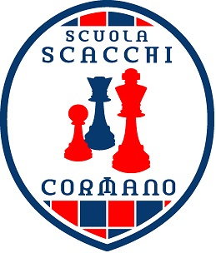 | 

Gran Torneo Scacchi di Fine Anno Scacchistico

TORNEO PRIMARIE - CLASSI QUINTE
Cormano, 10/06/2017

CLASSIFICA FINALE

Pos | Pts | ID | Title | NAME | Rtg | Buc1 | BucT | ARO.
1 | 4.5 | 1 |  | Anipan Alyssa CAMPIONESSA 2017 | 1440 | 17.5 | 18.5 | 1440.0
2 | 4.5 | 3 | NC | D'Alessio Fabio CAMPIONE 2017 | 1440 | 17.5 | 18.5 | 1431.5
3 | 4.0 | 9 | NC | Roa Ashley Terza Classificata | 1440 | 19.0 | 22.0 | 1431.5
4 | 4.0 | 7 | NC | Oliva Eleonora | 1440 | 19.0 | 20.0 | 1431.5
5 | 3.0 | 11 | NC | Ballona Rutti Ivan Alessandro | 1389 | 17.5 | 18.5 | 1440.0
6 | 3.0 | 4 | NC | Guglielmi Simone | 1440 | 15.5 | 16.5 | 1431.5
7 | 3.0 | 10 | NC | Zollo Asia | 1440 | 14.0 | 15.0 | 1440.0
8 | 2.0 | 6 | NC | Minasi Andrea | 1440 | 16.0 | 17.0 | 1431.5
9 | 1.0 | 8 | NC | Radaenu Elisa | 1440 | 17.0 | 18.0 | 1440.0
10 | 1.0 | 5 |  | Mickail Miriam | 1440 | 15.0 | 16.0 | 1431.5
11 | 0.0 | 2 | NC | Bianchi Matteo(W) | 1440 | 12.5 | 13.5 | 0.0

Tie Break legend:
Buc1 = Buchholz Cut 1
BucT = Buchholz Total
ARO. = Average Rating Opponents

Generato da Vega - www.vegachess.com
(Arbiter/Club : ASD SC CORMANO - ITA )
SC CORMANO - ITA )

